# Name: Abdurrahman Qureshi

# Roll no: 210451

## Practical no 4: -

Aim: Write PL/SQL Code to Create Procedures and Functions.

* Practical Related Questions

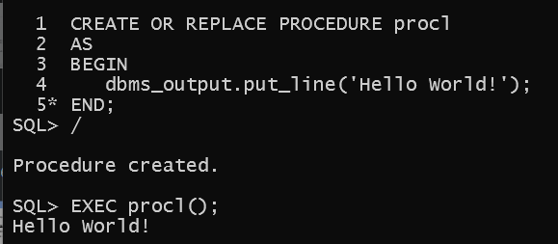

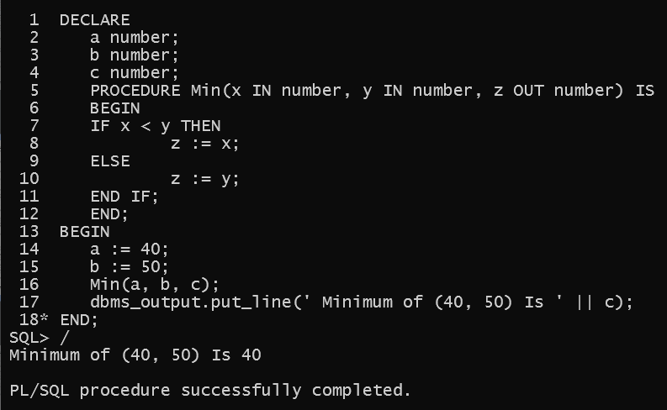

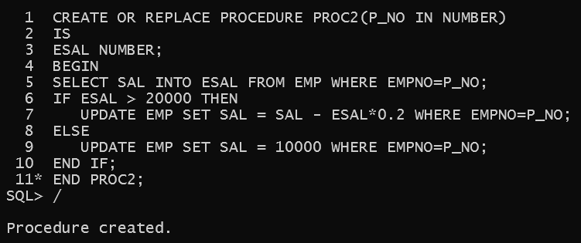

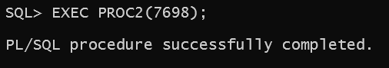

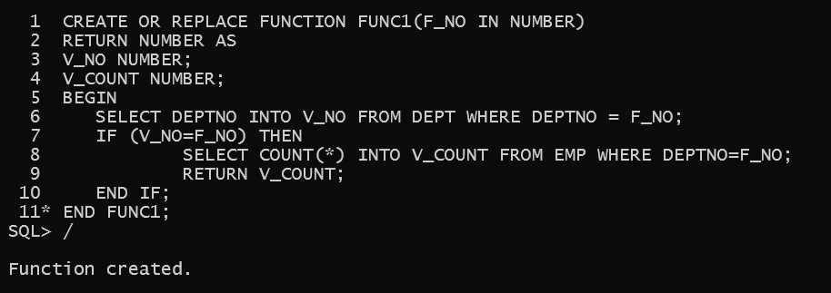

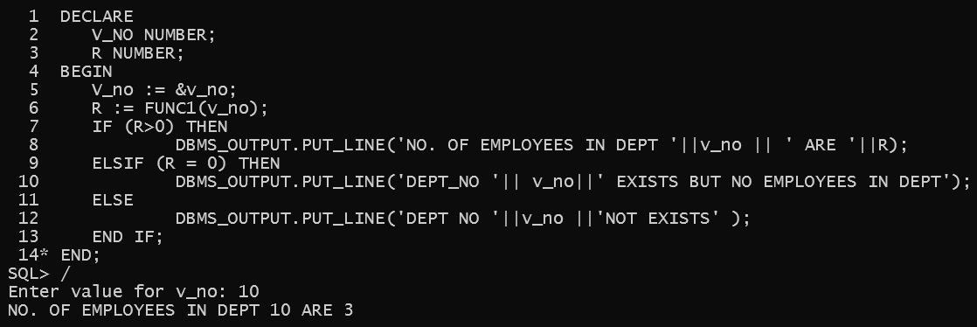

* Exercise

1. Write procedure to update the salary of all employees by 25%.

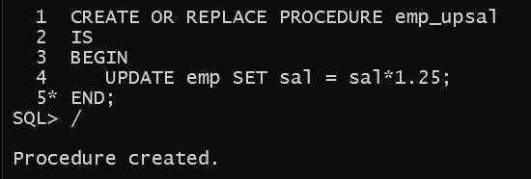

1. Write Function to calculate factorial of given no.

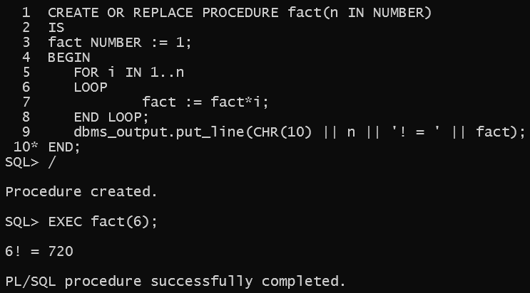

1. Write Function to display the empno, salary of employee Shreyas.

